CSS Activity 1: Box Model

Figure out if the element is inline or block-level. Justify your answer by running a code that satisfies each of the scenario below. Write a snippet of the code you used to prove your answer in the tables below and a brief explanation of why you considered it inline or block-level.

Example:

- Observing how its default width behaves

Element |  | Display (inline or block) | Test Code
 |  |  | <h1 style=”background-color:red”>Hello</h1>
h1 |  | block | Background color spanned the whole width of
 |  |  | h1’s parent container (body element)
B. Adjusting its height
Element |  | Display (inline or block) | Test Code
 |  |  | <small
small |  | inline | style=”background:blue;height:20px”>Hi</h1>
small |  | inline | The 20px height did not reflect on the
 |  |  | element

Tip: You can use the background or border properties to outline elements. For padding and margins, use your browser’s developer tool.

- Observing how its default position behaves

 | Element | Display (inline or block) | Test Code
1. | strong
2. | input (password)
3. | h1
4. | s
5. | form
6. | blockquote
7. | abbr
8. | h4
9. | nav

- Observing how its default width behaves

Element | Display (inline or block) | Test Code

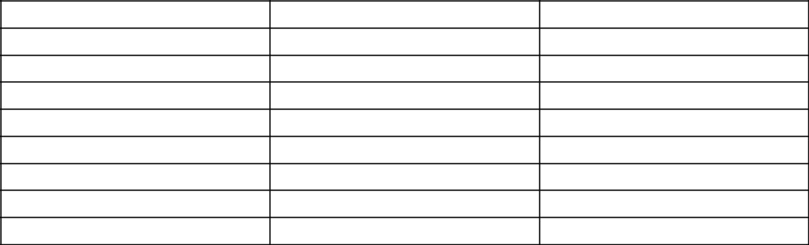
  - h2

  - em

  - ins

  - sup

  - li

  - dl

  - input (email)

  - select

  - footer

C.Adjusting its height

 | Element | Display (inline or block) | Test Code
1. | header
2. | span
3. | a
4. | button
5. | img
6. | input (checkbox)
7. | sub
8. | fieldset

- Adjusting its width
 | Element | Display (inline or block) | Test Code
1. | h5
2. | q
3. | del
4. | aside
5. | figure
6. | input (submit)
7. | h3
8. | small

- Adding padding on all sides
 | Element | Display (inline or block) | Test Code
1. | h6
2. | ol
3. | hr
4. | p
5. | div

6. | input (number)
7. | ul
8. | table
F. | Adding margin on all sides
 | Element |  | Display (inline or block) | Test Code
1. | dt
2. | dd
3. | input (radio)
4. | textarea
5. | input (text)
6. | input (file)
7. | article
8. | figcaption
9. | label

